A New Zealand Guide to Identifying Hazel Varieties

M Redpath. December 2010

This guide is intended to allow growers, nurseries, and gardeners to identify or check their hazelnut varieties. It is a joint project between the New Zealand Tree Crops Association and the Hazelnut Growers Association of NZ, assembled with financial assistance from the Ministry of Agriculture and Fisheries Sustainable Farming Fund as part of Project L08-088, “Assisting growers to achieve effective pollination in NZ hazelnut orchards”.

Most varieties covered in this guide were imported prior to 1990 by nurseries or research organizations such as the NZ Tree Crops Association and the DSIR (Dept. of Scientific and Industrial Research).

Over time, errors in the correct naming of some varieties have appeared. There are various ways that this happens: simple human error; seedlings establishing in propagation beds or among suckers collected from the base of cropping trees; propagation from unverified plant material; or poor record keeping.

These errors can have important ramifications when growers are planting commercial orchards and selecting combinations of varieties to provide pollinisers. It is essential that selected polliniser varieties have pollen that is compatible with the main crop variety and pollen is shed to coincide with the emergence of the red stigmas of the female flowers. This can only be assured if the varieties are correctly named.

New land owners who take over properties with unmapped hazel plantings may wish to identify the varieties present but have no local source of information.

Twenty years ago there were a number of mapped plant collections of hazel cultivars that could provide a reference for identification. Most of these have been removed and New Zealand now has just two mapped collections that contain most varieties.

The first is at Lincoln University and consists of a variety collection and two adjacent research plantings. The second is on private land at Wairata Forest Farm in the eastern Bay of Plenty. While these collections seem to be safe at present, history has shown that no collection can be considered to be permanent.
Therefore it is considered vital to the NZ hazelnut industry to collect and detail the characteristics of the named varieties held in these collections and make this information publicly available.

The characteristics of the trees of varieties originating overseas that are held in these collections have been checked against characteristics recorded in publications listed in the references and against nuts and trees of the same variety in the USDA National Clonal Germplasm Repository at Corvallis, Oregon, USA. A full report, The Identification of Hazelnut Varieties available in New Zealand” is available in .PDF format

Identifying hazel varieties.

Most varieties covered by this guide have been listed for sale in nursery catalogues over the last 20 years and are most likely to be present in orchards planted over that period. Owners of older plantings may have varieties that have not been offered for sale recently. If these older varieties or NZ selections are present in the collections at Wairata Forest Farm or Lincoln University, brief descriptions can be found in the report “The Identification of Hazelnut Varieties available in New Zealand”.

The characteristics of a variety’s nuts will usually allow growers to identify varieties commonly available in New Zealand. While it is possible for seedlings to have nuts that are similar to those of the parent, it is rare for all other characteristics (time of pollen shedding, flowering, bud characteristics, tree shape) to also be identical.

Therefore growers should start with nut characteristics to identify varieties. Once a probable variety has been selected, the winter flowering and bud characteristics can be used to confirm the identification. Any plants that do not fit all the listed characteristics are likely to be seedlings.

The nut characteristics listed on Table 1 allow a grower with a nut sample to move through a few key characteristics, starting with the shape, to a probable variety. Clicking on the variety name will access a description and photographs of nuts, green nut clusters, buds and catkins of that variety.

In the photographs of the nut characteristics, blanched kernels are shown on the right hand side of the photographs. Mostly these will show some white blanched areas, but kernels that do not blanch will appear identical to the unblanched kernels adjacent.

Table 2 covers the physical characteristics of the tree that can be observed during the winter and early spring. This table will be useful for nurseries that are dealing with mother beds or young trees that are not cropping, and as confirmation for growers who may suspect that they may have seedlings rather than named varieties.

Most terms used in this guide follow those prescribed in “Descriptors for Hazelnut (Corylus avellana L.)” (Bioversity, FAO, and CIHEAM. 2008).This publication is available online at <http://www.bioversityinternational.org.

Definitions of nut size and catkin size were not included in the above publication and have been defined below.

The nut characteristics of the varieties are defined using nuts from well grown mature trees in good growing climates. Some nut characteristics may differ when using nuts from trees in less suitable growing situations. For example, unpruned shaded trees or trees under moisture stress will often have a high proportion of shrivelled kernels or more fibre than normal. Mould and heavy fibre cover are more prevalent in damp seasons.

Bud and catkin characteristics are taken from vigorous growths on the outside of the canopy.

Definitions of the Nut Characteristics in Table 1:

Shape:
The six nut shapes are illustrated in Fig. 1 with a simple description of the terms given below.

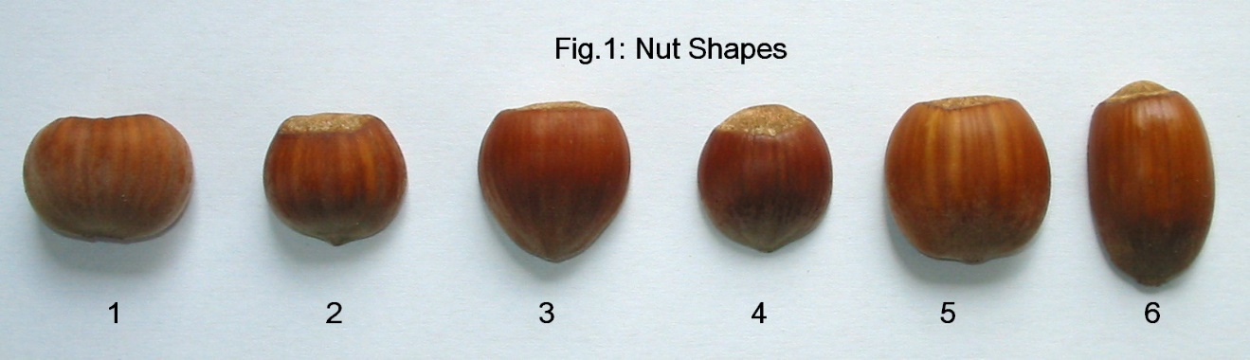

1: Oblate: length is less than the width, a “flat” nut.
Reference cultivar: Imperiale de Trebizonde.
2: Globular: length is about the same as width, a “round” nut.
Reference cultivars: Barcelona, Tonda Gentile delle Langhe.
3: Conical: length is greater than the width; cone shaped.
Reference cultivar: Merveille de Bollwiller.
4: Ovoid: length is greater than the width; oval shaped.
Reference cultivar: Negret/Appleby
5: Short subcylindrical: a slightly elongated nut.
Reference cultivar: Butler
6: Long subcylindrical: a long nut.
Reference cultivar: Kentish Cob

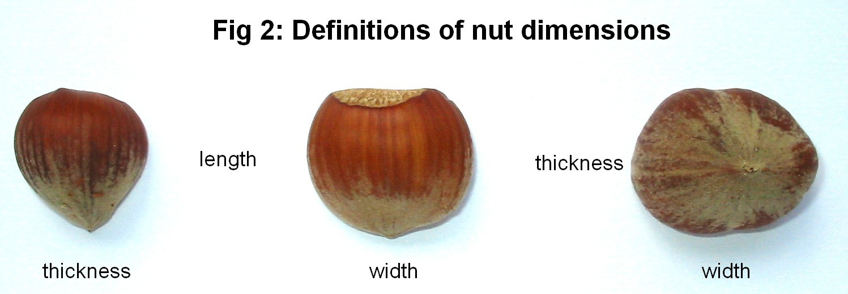

Length: Average of at least 25 nuts, measured from the most distant points along the main seed axis.
Width: average of at least 25 nuts, measured from the widest point perpendicular to the main seed axis.
Thickness: average of at least 25 nuts, measured at the widest point perpendicular to the suture.

Size:
Size is based on the average width of at least 25 nuts.
Large: Greater then 20mm, the diameter of a 10 cent coin.
Medium: 13 to 20 mm.
Small: Less than 13mm.

Shell colour:
This is the colour of the shell of freshly harvested nuts. Nut colour darkens as the nut dries.
Reference varieties are:
Light brown: Butler, Ennis.
Brown: Barcelona, Tonda Romana, Tonda di Giffoni.
Dark brown: Negret (similar to Appleby).
Dull, pale nuts, such as Alexandra, often have creamy pale shells when fresh, sometimes with hints of green shell. They dry to a pale brown.

Shell Striping:
Striping refers to the darker coloured stripes running down the smooth shell. This is distinct from the striping effect caused by the ribbed or corrugated surface of the shell
Ribbed shells are a distinctive feature of some varieties.

Kernel fibre:
Kernel fibre is the rough corky material adhering to the pellicle (the smooth brown skin on the kernel).

Blanching:
Blanching assesses the amount of pellicle removal after 20 minutes in an oven at 115degrees C (Thompson et. al. 1978). In the photographs, blanched kernels are shown on the right hand side.

None: No pellicle removal.
Poor: Less than 50% pellicle removal.
Medium: 50 – 75% pellicle removal.
Good: 70 – 90 % pellicle removal.
Excellent: More than 90 % pellicle removal.

Table 1: Nut characteristics
Shape | Size | Shell Colour | Shell Striping | Kernel Fibre | Kernel  Blanching | Variety
Oblate | medium | brown | few | medium | excellent | Nocchione
Globular - obl | medium | light brown | medium | light | poor | Tonda Romana
Globular - obl | medium | light brown | many | light | excellent | Tonda di Giffoni
Globular - obl | large | brown | med, corr | light | poor | Lansing
Globular | large | light brown | many, corr | none | poor | OSU 18-114
Globular | large | dull, pale | few | none | none | Plowright
Globular | large | light brown | many | light | medium | OSU 14-84
Globular | large | light brown | many | medium | excellent | Campanica
Globular | large | dark brown | few | medium | medium | Barcelona
Globular | medium | brown | few | light | excellent | Whiteheart
Globular | sm - med | brown | few | medium | excellent | TGDL
Conical | large | brown | few | none | good | M. de Bollwiller
Ovoid | large | light brown | many | none | none | Ennis
Ovoid | large | light brown | few | none | good | Royal
Ovoid | medium | dull, pale | few, corr | high | excellent | Gisborne
Ovoid | med- small | dark brown | few | light | excellent | Appleby
Sht.subcylind. | large | light brown | medium | light | poor | Butler
Sht.subcylind. | med-large | dull, pale | few, corr | medium | poor | Alexandra
Sht.subcylind. | med-large | brown | few | light | good | San Giovanni
Long subcyl. | med-large | brown | few | light | none | Kentish Cob
Long subcyl. | med-large | brown | few, corr | none | none | Keen’s Late
Long subcyl. | med-small | brown | few | none | good | Nott/Wisp/WSF

Abbreviations: Obl. = oblate; Sht. = short; subcyl. = subcylindrical; sm = small;
med = medium; corr = corrugated shell surface; TGDL = Tonda Gentile delle Langhe;
Nott. = Nottingham; Wisp. = Wispit; WSF = White Skinned Filbert.

Definitions of the winter flowering/bud characteristics in Table 2

Relative dates of pollen shed and female flowering.
The dates of these characteristics are dependent on the seasonal temperature characteristics and can change from season to season and differ between regions. However, the relative timing for these events for different varieties is usually reasonably constant (Thompson et al, 1978).

Information on timing in southern growing areas is limited for varieties other than Whiteheart and its pollinisers so the information for this table is based on averaged values from the Wairata Forest Farm hazel collection. Comparisons with flowering records from Otago and Canterbury over the 2010 season indicate that this information will be applicable to most of New Zealand.

Merveille de Bollwiller is a variety with very distinctive characteristics that is present in most plantings and is used here as a reference variety. Merveille de Bollwiller sheds pollen late, flowers late, and leaves emerge late.

In most parts of New Zealand, June would be considered early for pollen shedding and flowering, July would be mid-season, August is late and September is very late.

Relative time of bud burst.

Calendar dates, collected from the Wairata Forest Farm collection and averaged over the last seven years of data; illustrate the date of bud burst relative to Merveille de Bollwiller.

Relative time of budburst | Calendar dates | Reference variety
Very early | Early August | Tonda di Giffoni
Early | Late August | Lansing
Intermediate | Early September | Barcelona
Late | Late September | Merveille de Bollwiller
Very late | October | Alexandra

Catkin Size.
Catkin length: Long: most greater than 25 mm long
Short: most less than 25 mm long
Catkin thickness: thin: most 4 to 5 mm thick.
medium: most 5 to 6 mm thick.
thick: most 6 mm or thicker.

Bud shape and colour.
These are typical buds on vigorous growth in mid-winter.

Reference varieties for bud shape are:
Globular: Whiteheart, Kentish Cob.
Ovoid: Barcelona
Pointed: Merveille de Bollwiller

Usually buds have varying degrees of green background colour. The listed colour is the dominant overlying colour.

Table 2: Winter flowering and bud characteristics

Relative date of pollen shed | Relative date of female flowering | Relative time of bud burst | Catkin size | Bud shape and colour | Variety
Very early | midseason | Very early | Long, medium | Green, globular | TGDL
Very early | midseason | early | Long, medium | Green, globular | Royal
Very early | late | intermediate | Short, medium | Bn/gn, ovoid | Butler
Early | midseason | intermediate | Short, medium | Brown, globular | Appleby
Early | Very early | Very early | Long, medium | Green, globular | San Giovanni
Early | early | early | Short, thin | Bn/gn, globular | Campanica
Early | early | early | Short, thin | Green, globular | Nocchione
Early | Mid - late | intermediate | Long, medium | Bn/gn, ovoid | Barcelona
Early - mid | Early - mid | Very early | Short, thin | Bn/gn, globular | Tonda di Giffoni
Early - mid | Early - mid | Early | Long, medium | Green, ovoid | Lansing
Early - mid | midseason | intermediate | Short, medium | Bn/gn, globular | Tonda Romana
Early - mid | Mid - late | intermediate | Short, medium | Red/gn, pointed | OSU 14-84
Midseason | midseason | Very early | Long, medium | Red/gn, ovoid | Gisborne
Midseason | Mid - late | late | Short, medium | Bn/gn, ovoid | OSU 18-114
Mid season | Late – very late | late | Short, medium | Bn/gn, ovoid | Ennis
Midseason | Late - very late | intermediate | Long, thick | Bn/gn, globular | Whiteheart
Late | Late | Late | Long, medium | Red, pointed | M. de Bollwiller
Late | Late | Late | Short, thin | Bn/gn, globular | Plowright
Late | Very late | Very late | Long, thick | Red/gn, conical | Alexandra
Late | Late | Late | Long, medium | Bn/gn, ovoid | Kentish Cob
Very Late | Late | Very Late | Long, medium | Bn/gn, globular | Keen’s Late

Abbreviations: Mid. = midseason; Bn. = brown; gn. = green; TGDL = Tonda Gentile delle Langhe; M. de Bollwiller = Merveille de Bollwiller.

References cited:

Baldwin, B. 2007. The Identification of Hazelnut Clonal Material. Key characteristics of varieties commonly available in Australia. Horticulture Australia Ltd. Pub. No. NT04010. 32p.

Bergoughoux, F., Germain, E., and Sarraquigne, J-P. 1978. The Hazelnut. Production and Culture. INVUFEC: Paris (Translated by J.J.M. Leerschool). 98p

Koksal, A.I. (ed.) 2000. Inventory of Hazelnut Research, Germplasm and References.
http://www.fao.org/docrep/003/x4484e/x4484e00.htm. Accessed December 20th 2010.

Thompson, M.M., Romisondo, P., Germain, E., Vidal-Barraquer, R., Tasias-Valls, J. 1978. An evaluation system for filberts (Corylus avellana L.). Hortscience, 13(5): 514-517.

Thompson, M.M. 1981. Unpublished transcript from tape recorded at Harrison’s Trees- Maxine Thompson describes hazelnuts imported by NZTCA.

USDA. 2010. USDA Agricultural Research Service, Hazelnut Clonal Germplasm Repository – Corvallis, GRIN database www.ars.usda.gov/cor/catalogs/corcult.
Accessed February 10th and 17th 2010.
Descriptions of hazelnut varieties commonly available in New Zealand.

Appleby

Synonyms: NZ Barcelona.

Appleby originated from plants labelled as Barcelona at the Appleby Research Station, Nelson, New Zealand. The error in identification was detected by Prof. Maxine Thompson in 1981 and it was assumed that it was a Barcelona seedling. It was sold as “NZ Barcelona” during the 1980’s but was renamed Appleby in 1989 to avoid confusion with the true Barcelona.

Appleby forms a low to medium vigour bush with numerous suckers. The husk is about the same length as the nut and most nuts fall free. Appleby is susceptible to bacterial blight and big bud mites. Pollen is shed early, flowering is mid-season.

Appleby has moderate to high yields of a medium sized nut. The nuts are rather irregular in shape, varying from very round nuts to slightly elongated, flattened nuts (especially with heavy crops and clusters with multiple nuts). Kernels are clean, oval to slightly elongated in shape, and blanch well. 47% kernel by weight.

Appleby cropped well in Hawke’s Bay and Marlborough but not in Canterbury. It is very similar to the Spanish variety, Negret.

Alexandra

A New Zealand selection (H/6A/641) from”Nutty” Duncan’s property near Alexandra, Central Otago. It forms a large vigorous, open, spreading tree with few suckers when propagated from suckers or layers. It is difficult to strike roots using layering or tie off layerage and Alexandra is usually sold as grafted plants. The husk is about the same length as the nut and most nuts fall free of the husk. It is susceptible to big bud mites and moderately susceptible to bacterial blight. It sheds pollen over a long period late in the winter. Flowering and bud burst are very late.

If other late pollinisers are present, Alexandra has heavy yields of nuts. The nuts are flattened, blocky in shape, with a dull pale cream/brown colour drying to a dull grey/brown. Nuts have very thick shells, with small elongated kernels with a moderate to light fibre cover. Percent kernel 32 – 34%

Alexandra is the main late polliniser used for late flowering cultivars such as Whiteheart and Butler. It has large numbers of catkins, often in large “bunches” of more than 10 catkins.

Auckland No. 2

Auckland No.2 was selected as a potential late polliniser from a plant at the DSIR Research Station at Mt. Albert, Auckland. It is not in the Wairata or Lincoln plant collections so information on the tree, nut, and flowering characteristics is limited. The tree is very similar to Alexandra in form. Flowering and pollen shed are very late. No information is available on its compatibility with late flowering varieties.

Yields are usually very low, probably due to the very late flowering. Nuts are similar to Alexandra but with a shell that is less downy and rounder in shape.

Barcelona

Synonyms: Fertile de Coutard, Grosse Blanche de Angleterre, Castanyera.

An old cultivar widely distributed in Western Europe, probably originating in Spain, and the main cultivar grown in Oregon, USA for the last century. It is very vigorous, forming a large spreading tree. The husk, one third longer than the nut, opens and sheds the nut freely. Barcelona is very resistant to big bud mites (USDA, 2010). It is susceptible to bacterial blight and is often affected by “brown stain” which causes a large number of misshapen nuts. It flowers mid-season.

Barcelona is very productive, yielding a medium to large dark brown nut with a shell of medium thickness. The kernel is often fibrous but blanches moderately well with a good flavour. Percent kernel 39 – 42%.

Excellent quality Barcelona nuts have been produced in Marlborough and Wairarapa but kernel quality declines in cool damp climates due to increased fibre adhering to the kernel.
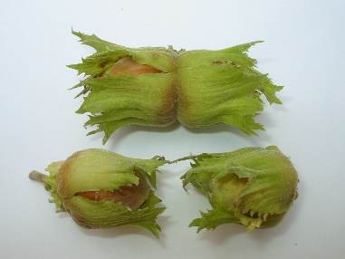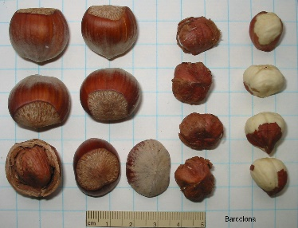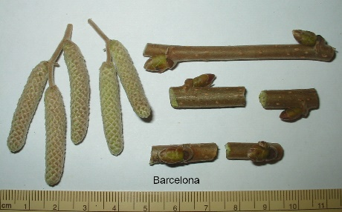

Butler

Butler originated as a seedling from Joseph Butler’s orchard in Oregon, USA and was introduced into cultivation in 1957. It appears to be a cross between Barcelona and Daviana (USDA, 2010). It is very vigorous with an erect tree form. It is free husking, nut drop occurs over a long period. It is susceptible to bacterial blight and big bud mites. It drops pollen for a long period early in the season but the female flowers are late.

Butler is very productive, with a tendency to biennial production (USDA, 2010). Nuts have a high percent kernel (47 – 49%) with an attractive kernel. The kernels do not blanch and are sometimes considered to have a bland flavour. They have yielded well in most parts of New Zealand.

Butler has a distinctive blocky nut shape. It can be distinguished in winter by the erect tree form, and early pollen shedding compared to the late flowering.

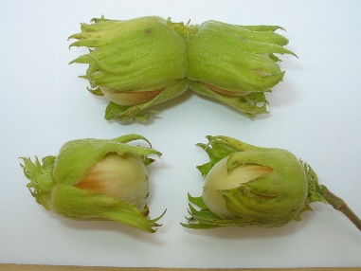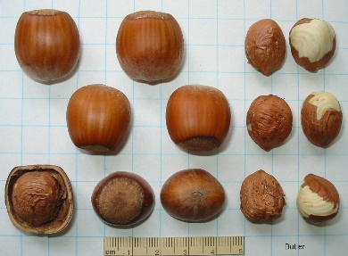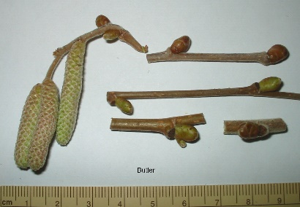

The false “Butler”:
An unknown selection has been sold as Butler over the last 10 years. This appears to be a seedling. Information is limited but it is easily distinguished from the true Butler. It forms an open bush of moderate vigour. Pollen is shed before Merveille de Bollwiller. Winter buds are green and globular in shape. Nuts are small, subcylindrical, and thick shelled with a heavy fibre cover.

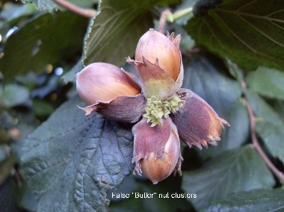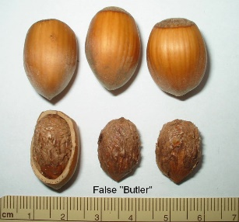

Campanica
Synonyms: Camponica, Nocella noce, Campaneca, Campatica, Campania.

Campanica is an Italian variety commonly grown in the Naples region (Bergoughoux et al, 1978). It is a vigorous erect tree, coming into leaf early in the spring. The husk is about 50% longer than the nut and free husking (less than 5% fall in the husk (USDA, 2010). It is moderately susceptible to bacterial blight and big bud mites. Both pollen shed and flowering are early.

Campanica is very productive. The medium to large nuts are attractive, with glossy striped shells with a distinct groove down one side. The nuts have a high crackout, the kernels tend to have some fibre but blanch moderately well and have a strong hazel flavour. They are used both for direct consumption as well as for the industrial manufacturing of sweets (USDA, 2010). Percent kernel 44 – 48%.

Campanica has cropped well in New Zealand but it can have problems with mouldy kernels. The trees could be mistaken for Butler in winter but can be distinguished from Butler by early flowering, and early bud burst.

Ennis

Ennis was developed in Washington, USA, and was introduced around 1940. It is probably a cross between Barcelona and Daviana. It was selected primarily for its large nut size and yielding capacity (USDA, 2010). It forms a vigorous tree with an open crown. Ennis is late coming into leaf. There are usually just one or two nuts per cluster. The husk tends to clasp the nut and many nuts fall in the husk. It is moderately susceptible to bacterial blight and big bud mites. Pollen is shed mid-season, female flowering is mid to late. Many flowers are borne on the catkin peduncles (stalks). Ennis is not an effective polliniser. Its catkins are small and release a high proportion of non-viable pollen (USDA, 2010).

Ennis is very productive with large attractive nuts. The shell is pale, glossy, striped, and easily cracked. Kernels are usually free of fibre and do not blanch. Percent kernel 43 – 49%.In Oregon the kernels are generally plump and have a less wrinkled appearance than kernels of most other large-sized nuts (USDA, 2010). However, trials in Australia reported that in many instances, kernels of Ennis were poorly filled and shrivelled (Baldwin et al, 2007). This has been observed in parts of NZ (pers. comm. D. Murdoch, I. Burney 2009). Good quality Ennis nuts are produced in Marlborough so Ennis may be a very site specific cultivar.

Gisborne

The Gisborne variety was selected as a potential late polliniser from a tree at the DSIR research station at Gisborne, New Zealand. It is vigorous with few suckers forming a large spreading tree. The husk is about 50% longer than the nut but is strongly split and most nuts fall free of the husk. It is moderately susceptible to bacterial blight but seems to be resistant to big bud mites. Pollen shedding and flowering are midseason.

Performance data for Gisborne is limited but it has yielded well in the Bay of Plenty and Wairarapa. The nuts are ribbed and dull light brown, with a heavy fibre cover on the kernel. The kernels blanch well. Percent kernel 38-40%.

Gisborne is very similar to Alexandra and reports of early flowering “Alexandra” trees in the 1980’s usually turned out to be Gisborne. The most distinct differences are the earlier dates for pollen shedding and bud burst for Gisborne.

Keen’s Late

A White Skinned Filbert seedling selected for late pollen from Michael Keen’s garden in Hastings, New Zealand. It forms an erect tree of moderate vigour. Husks and nuts are similar to Kentish Cob. It appears to be susceptible to bacterial blight and moderately susceptible to big bud mites. Pollen shed is very late, extending well into early September. Female flowers emerge before or about the same time as catkin extension in the North Island but little is known of its performance in other growing areas.

Keen’s Late crops well. Nut quality is poorer than Kentish Cob. The shell is more downy and thicker with a flat scar. Percent kernel 26 – 30%

Kentish Cob
Synonyms: Du Chilly, Longue d’Espagne.

Kentish Cob originated as a seedling selection in Kent, England. In Kent, the nuts are harvested green for the fresh market. The tree is of relatively low vigour, semi-erect and productive. It is late coming into leaf. The husks extend beyond the nut, 50 to 60 % of the nuts fall free. Pollen shed is late, making it a useful polliniser. It is moderately resistant to big bud mites (USDA, 2010) and susceptible to bacterial blight.

The nuts are large, long, and flattened. The shell is thin and the nuts are easily cracked. The kernels are long, free of fibre, sweet and do not blanch 48% kernel by weight (USDA, 2010).

Kentish Cob has sometimes been used as a late polliniser in New Zealand.

Lansing

Lansing originated in Oregon.

The tree is semi-erect and vigorous. Pollen shed and flowering are mid-season. Catkins are long and green. Leaves fall late but bud burst is early. Husks are the same length as the nut and most nuts fall free of the husk. Lansing is resistant to blight and big bud mites.

Lansing is productive with large attractive round nuts. The shell is thin, brown with a distinct stripe. They are easily cracked. The large round kernels are usually free of adhering fibre but are susceptible to mould. Percent kernel 44 – 50%

Lansing is a very productive, healthy variety that has been used as an early polliniser for Whiteheart in the South Island. It is distinguished by its mid season pollen and flowering, and early bud burst. The nut is a similar size to Ennis but darker brown and globular to oblate in shape rather than ovoid.

Merveille de Bollwiller
Synonyms: Hall’s Giant, Geante de Halle, Halle’sche Reisennuss.

The name Hall’s Giant is used in Australia and the USA. It originated in 1788 as a seedling selection by C.G. Bultner at Halle, Germany (USDA, 2010). The tree is vigorous and spreading with dark green leaves. Merveille de Bollwiller is late coming into leaf. It has distinctive dark red to purple buds. Catkins have a purple blush. It is an excellent polliniser, bearing heavy crops of healthy catkins and it is compatible with most other varieties. Pollen is shed late, often for a short period. Flowering is late. The husk is slightly longer than nut but most nuts fall free of the husk. Merveille de Bollwiller is resistant to bacterial blight and big bud mites.

Merveille de Bollwiller has attractive medium to large nuts but it often has low yields. The shell is thick, brown and glossy. The kernel is round to oval, firm and free of fibre. It blanches well. Percent kernel 36 – 41%

Merveille de Bollwiller is frequently used as a polliniser as it is compatible with most other varieties. It has very distinctive reddish or purple buds and catkins.

Nocchione
Synonyms: Montebello, Santa Maria del Gesu.

An Italian variety grown in Sicily and used as a polliniser for Tonda Romana in Latium (Koksal, 2000).

It forms an open tree of low to moderate vigour.

Pollen shed and flowering are early. The husk is about the same length as the nut and most nuts fall free.

Nocchione is moderately susceptible to bacterial blight but are resistant to big bud mites.

Nocchione yields heavy crops of medium sized, oblate, thick shelled nuts. The kernels are round with moderate fibre adhering, but they blanch well. Percent kernel is low (35-38%)

Nottingham.

Plants purchased as Nottingham in New Zealand do not bear any resemblance to the Nottingham in the USDA collection at Corvallis. The plants appear to be identical to White Skinned Filbert

The OSU selections.
A number of selections from the Oregon State University breeding programme were imported on the recommendation of Prof. Maxinne Thompson. For many years these were referred to as the “Maxinne Thompson” or “MT” selections. Only two have been propagated for sale, OSU 14-84 and OSU 18-114. Three other selections are present in the Wairata or Lincoln collections.

OSU 14-84
Synonyms: MT 14-84

OSU 14-84 is a Barcelona-Daviana cross originating from the Oregon State University breeding programme (Thompson, 1981). It forms a vigorous semi-erect tree. Flowering and pollen shed occurs mid-season. The husk is about the same length as the nut, most nuts fall free of the husk. OSU 14-84 is moderately susceptible to bacterial blight but is resistant to big bud mites (Thompson, 1981)

OSU 14-84 bears good yields of an attractive large, round, thin shelled nut. The kernel is round, clean and blanches moderately well. Percent kernel 50-55%.

There is little information on the performance of OSU 14-84 outside of the Wairata Forest Farm collection. Thompson (1981) noted that it tended to have many blanks and trees became more productive as they get older. It may be only suited to the home garden market as the thin shell tends to be damaged during harvesting with large commercial harvesters

OSU 18-114
Synonyms: MT 18-114

OSU 18-114 is a Barcelona – Royal cross originating from the Oregon State University breeding programme (Thompson, 1981). It forms a vigorous erect tree with few suckers. Pollen is shed mid-season, flowering is late. Husks are slightly longer than the nut and very flared at the ends. Many nuts fall in the husk. It appears to be resistant to bacterial blight and is moderately susceptible to big bud mites (Thompson, 1981).

OSU 18-114 has moderate to low yields of a very large nut. Kernels are clean but blanch poorly. There are usually many empty nuts; the percent kernel of good nuts is about 43%.

Plowright
Synonyms: H/10Tok/1022

Plowright is a Kentish Cob seedling selected by Peter Plowright, Tokoroa, New Zealand. The tree is vigorous with a very erect growth habit and few suckers. Flowering and pollen shed are late, similar to Merveille de Bollwiller. The husk is shorter than the nut and most nuts fall free of the husk. Plowright is susceptible to bacterial blight and big bud mites.

The limited evidence available indicates that Plowright is moderately productive. The medium sized nuts are round and very pale at harvest, turning a pale downy brown as they dry. They have pronounced grooves on both sides. The kernels are free of fibre and do not blanch. Percent kernel 38 – 41%

Royal

Royal, a Barcelona x Daviana cross, was discovered in Stayton, Oregon, in 1930 by E. Roy. The tree is vigorous and semi-erect. Pollen shed is very early, flowering is mid-season. Most nuts fall free of the husk. Royal is susceptible to big bud mites (USDA, 2010).

Royal yields a medium to large nut with a thin shell. Kernels are clean, elongated, and blanch moderately well.

Little is known about the performance of Royal in New Zealand. It crops moderately well in the eastern Bay of Plenty.

San Giovanni

San Giovanni is widespread in the Naples and Salerno areas and in the well sheltered and exposed areas of Avellino (USDA, 2010).

It forms an upright vigorous tree. In warm climates it is almost semi-evergreen, holding its leaves until July with new leaves emerging in early August.

Pollen shed and flowering is early. It has distinctive pale pink stigmas.

The husk is about 50% longer than the nut and many nuts fall in the husk.

Susceptible to big bud mites and bacterial blight.

San Giovanni is productive. The medium sized elongated nuts yield an elongated kernel with a light fibre cover. Kernels blanch well. Percent kernel is high (49%).

Tonda di Giffoni

Tonda di Giffoni is an Italian variety of very ancient origin, grown in the province of Salerno (region of Naples). The tree is vigorous and semi-erect (Bergoughoux et al., 1978). It holds its leaves late into the autumn and the new leaves emerge very early (mid August in the Bay of Plenty). Flowering and pollen shed are mid-season. The husk is slightly longer than the nut, many nuts fall in the husk. Tonda di Giffoni is resistant to bacterial blight, and slightly susceptible to big bud mites.

Tonda di Giffoni is very precocious and productive. The medium sized nuts are round, brown with a distinct stripe and very pronounced grooves on the sides. The kernels are round, often grooved, and may have light fibre. They blanch very well, with almost complete pellicle removal. Percent kernel 44-47% (Bergoughoux et al., 1978).

Tonda di Giffoni has yielded well in most parts of New Zealand but has problems with high levels of mould and/or blanks in some orchards. Bergoughoux et al (1978) note that it is sensitive to frosts in spring so may be best suited to warm dry areas. It has relatively low chill requirements for catkins and vegetative buds and may be well suited to areas with mild winters and low chilling hours. It grew well at all sites in the Australian field experiments (Baldwin, 2007).

Tonda Gentile delle Langhe
Synonyms: Ronde du Piemont, Tonda Gentile del Piemonte.

Tonda Gentile delle Langhe is the main hazel variety grown in the Piedmont area of northern Italy. The tree is moderately vigorous with a semi-erect open tree form. Pollen is shed very early but flowering is late. Bud burst is early. The husk is slightly longer than the nut and nuts fall free of the husk. It is susceptible to bacterial blight and very susceptible to big bud mites.

Tonda Gentile delle Langhe has only moderate to low yields. Nuts are medium to small, round with many trilobal in shape. Kernels have a light to moderate fibre cover but blanch well. There are often a high proportion of mouldy kernels. Percent kernel 39 – 42%

TGDL is highly valued by the chocolate industry because of its small round kernel, excellent blanching ability and excellent flavour (Bergoughoux et al, 1978). However it has not performed well in New Zealand.

Tonda Romana
Synonyms: Tonda Gentile Romana, Tonda Gentile di Viterbo.

Tonda Romana is an Italian variety of very ancient origin that constitutes the principal variety in the hazelnut orchards of Viterbo region north of Rome (Bergoughoux et. al., 1978). The tree is of moderate to low vigour, semi-erect in form, and has many suckers.
The husk is slightly longer than the nut; most nuts fall free of the husk. Pollen shed and flowering are mid-season. Tonda Romana is resistant to big bud mites but is rather susceptible to bacterial blight.

Tonda Romana has moderate to high yields. The nut is medium to small in size, round, with a dull light brown shell. Kernels are round, usually free of fibre and do not blanch. Percent kernel 44-48% (Bergoughoux et. al, 1978).

There many selections of hazel with very similar nut characteristics named “Tonda Romana” (pers.comm S. Mehlenbacher, 2008). Nuts from the New Zealand trees seem to be identical to those viewed in Prof. Mehlenbacher’s collection and to one of the accessions in the USDA NCGR Corylus collection at Corvallis. Nuts can look similar to smaller Nocchione and Tonda di Giffoni nuts but Tonda Romana is distinguished from these varieties by its poor blanching ability.

Webb’s Prize Nut

The selection sold as Webb’s Prize Nut in New Zealand differs from the tree in the USDA collection at Corvallis. It resembles the plant in that collection labelled Du Chilly or Kentish Cob.

Whiteheart
Synonyms: Some older NZ orchards may have Whiteheart recorded as Waterloo, Whatnot, or numbers H/1M/164, 165, 166; H/11H/1101; H/10Hin/1021; or H/10TeK/1240.

Whiteheart is the main variety grown commercially in New Zealand. It was selected in the 1980’s from a number of plantings of a variety sold as Waterloo sold by Duncan and Davies.
The tree has low vigour, an erect form, and suckers strongly. The husk is nearly twice as long as the nut and clasps the nut tightly. Many nuts fall in the husk. Clusters often have 3 to 8 nuts per cluster. Pollen is shed mid-season but flowering is very late. Whiteheart is susceptible to bacterial blight and big bud mites.

Whiteheart has moderate to low yields. The medium sized, round nut has a shiny brown, thin shell. Kernels are round, free of fibre, and blanch very well. Percent kernel 47-50%

White-skinned Filbert/ Wispit/Nottingham

Plants sold in New Zealand under these names are indistinguishable and are probably the same cultivar. It is probable that they are the variety called White Filbert in the USDA collection. Other names used for this variety are: Avelline Blanche, Witpit Lambertsnoot, and Weiss Lamberts Nuss. It is a very old cultivar, being known in Europe since the 1600’s (USDA, 2010).
They form low vigour, spreading bushes with many suckers. The husk is twice as long as the nut and clasps it tightly. Clusters often have 3 to 8 nuts per cluster, many falling as a complete cluster with nuts held tightly in the husk. Pollen is shed mid-season; flowering is often split between some early flowers and a late flowering. They are susceptible to bacterial blight and big bud mites.

Nuts are small to medium long nuts. The shell is thin and the clean kernel has a strong hazel flavour. Kernels often have a distinctive curved suture running from the base to the apex (USDA, 2010). Percent kernel 50 – 52%

These varieties have sometimes been used as pollinisers for Whiteheart. White Avelline has S alleles 5 and 10 in the pollen (Mehlenbacher, 2002) and is therefore incompatible with Whiteheart (S2S10).

Waiau pollinisers

Waiau 1, 2 and 3 are late pollinisers sold by NZ Hazelnut Nurseries. Insufficient information on these selections is available at present to define their characteristics.

